# Measurable and Progress from maladaptive behaviors.

|  |  |  |  |  |  |
| --- | --- | --- | --- | --- | --- |
| Maladaptive Behaviors | Baseline Date:2017-09-23to2017-09-25 | Current average per week (3/31/2020) | % of Reduction(BL-average/ BL)*100 | Status | Updated STO (3/31/2020) |
| Self-Injurious behavior | 21 incidents per weeks | 19 incidents per week. | 8% | In progress | Sto1(MASTERED 2018-05-26). Sto2(MASTERED 2020-01-25). Currently: STO 3(Initiated 2/1/2020) |
| Physical Aggression | 28 incidents per weeks | 22 incidents per week. | 23% | In progress | Sto1(MASTERED 2018-05-12). Sto2(MASTERED 2018-11-30). Currently: STO 3(Initiated 12/1/2018) |
| Property destruction | 21 incidents per weeks | 19 incidents per week. | 8% | In progress | Sto1(MASTERED 2018-05-12). Sto2(MASTERED 2020-01-25). Currently: STO 3(Initiated 2/1/2020) |
| Tantrum | 35 incidents per weeks | 30 incidents per week. | 13% | In progress | Sto1(MASTERED 2018-01-20). Sto2(MASTERED 2018-01-20). Sto3(MASTERED 2018-05-12). Sto4(MASTERED 2018-12-29). Currently: STO 5(Initiated 1/1/2019) |
| Argumentative/Defiant behavior | 35 incidents per weeks | 27 incidents per week. | 24% | In progress | Sto1(MASTERED 2018-01-20). Sto2(MASTERED 2018-11-17). Currently: STO 3(Initiated 12/1/2018) |
| Disruption | 28 incidents per weeks | 15 incidents per week. | 46% | In progress | Sto1(MASTERED 2018-05-05). Sto2(MASTERED 2018-11-24). Sto3(MASTERED 2020-03-21). Currently: STO 4(Initiated 4/1/2020) |
| Verbal Aggression | 28 incidents per weeks | 22 incidents per week. | 23% | In progress | Sto1(MASTERED 2018-10-20). Sto2(MASTERED 2020-02-29). Currently: STO 3(Initiated 3/1/2020) |
| Lying behavior | 49 incidents per weeks | 39 incidents per week. | 21% | In progress | Sto1(MASTERED 2018-01-20). Sto2(MASTERED 2018-01-20). Sto3(MASTERED 2018-04-14). Sto4(MASTERED 2018-11-17). Sto5(MASTERED 2019-12-28). Currently: STO 6(Initiated 1/1/2020) |
| Task refusal | 56 incidents per weeks | 43 incidents per week. | 23% | In progress | Sto1(MASTERED 2018-01-20). Sto2(MASTERED 2018-01-20). Sto3(MASTERED 2018-01-20). Sto4(MASTERED 2018-01-20). Sto5(MASTERED 2018-11-17). Currently: STO 6(Initiated 12/1/2018) |
| Stereotype Behaviors | 63 incidents per weeks | 54 incidents per week. | 13% | In progress | Sto1(MASTERED 2020-02-29). Currently: STO 2(Initiated 3/1/2020) |
| Out of sit behavior | 56 incidents per weeks | 46 incidents per week. | 17% | In progress | Sto1(MASTERED 2020-02-29). Currently: STO 2(Initiated 3/1/2020) |
| Total of Reduction (%) | - | - | - | - | 20.3427128427 |

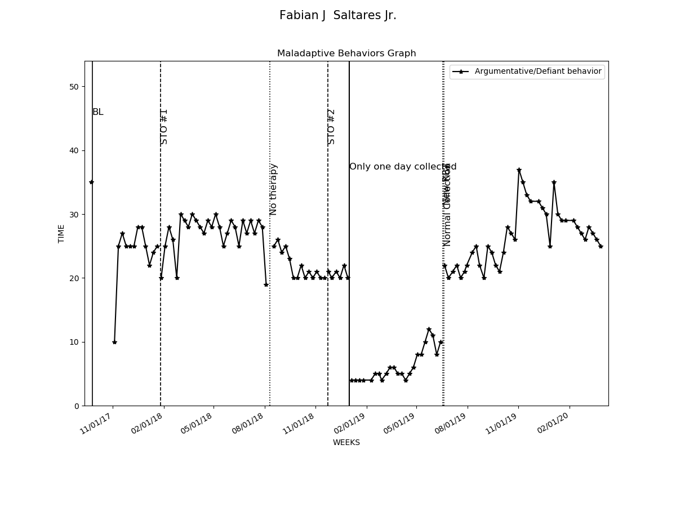

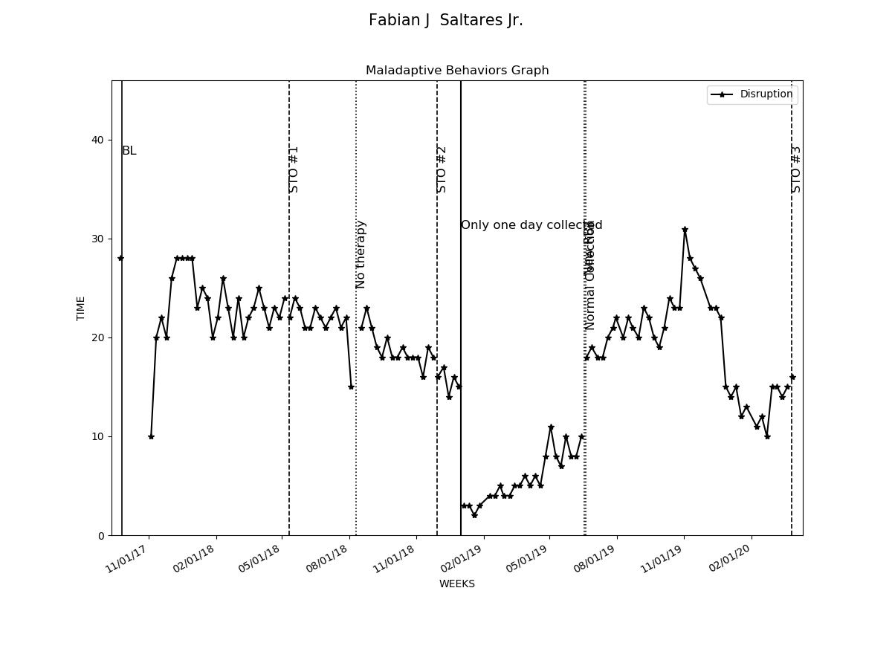

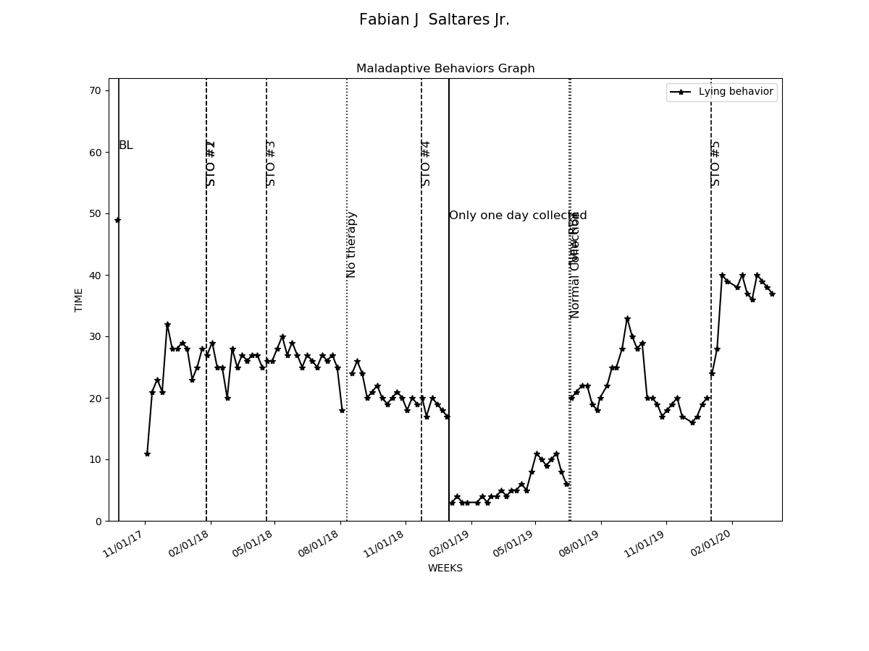

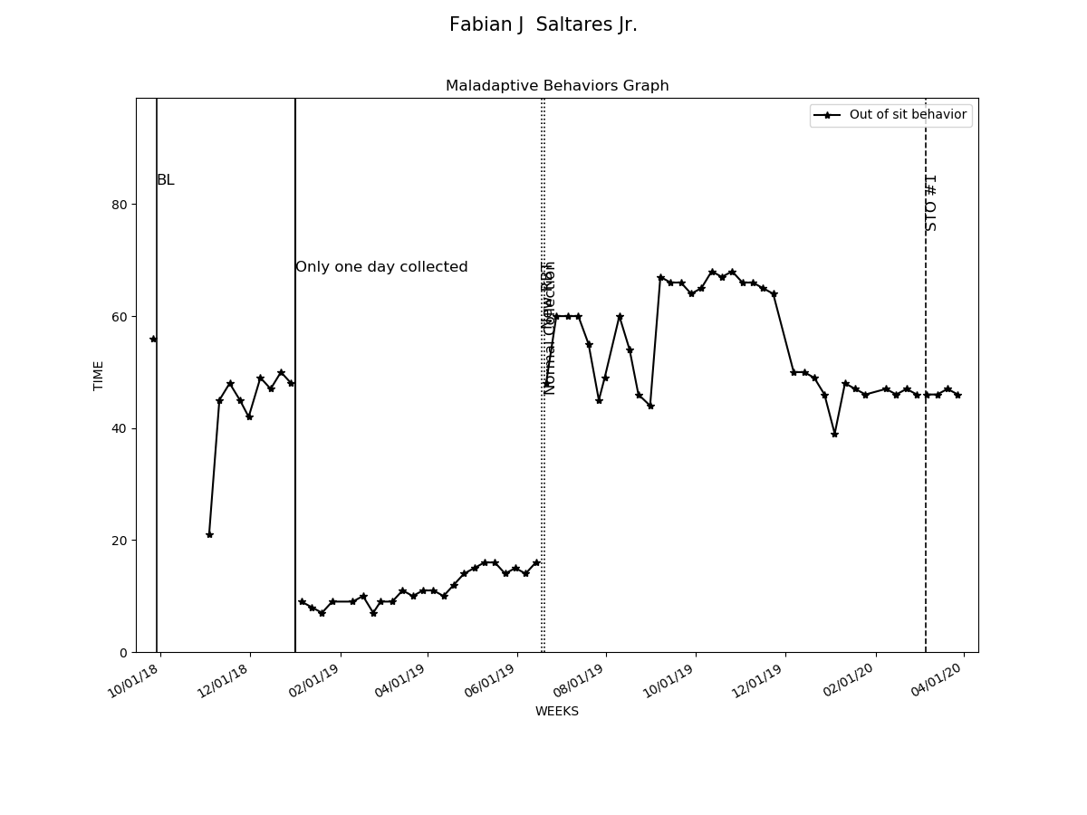

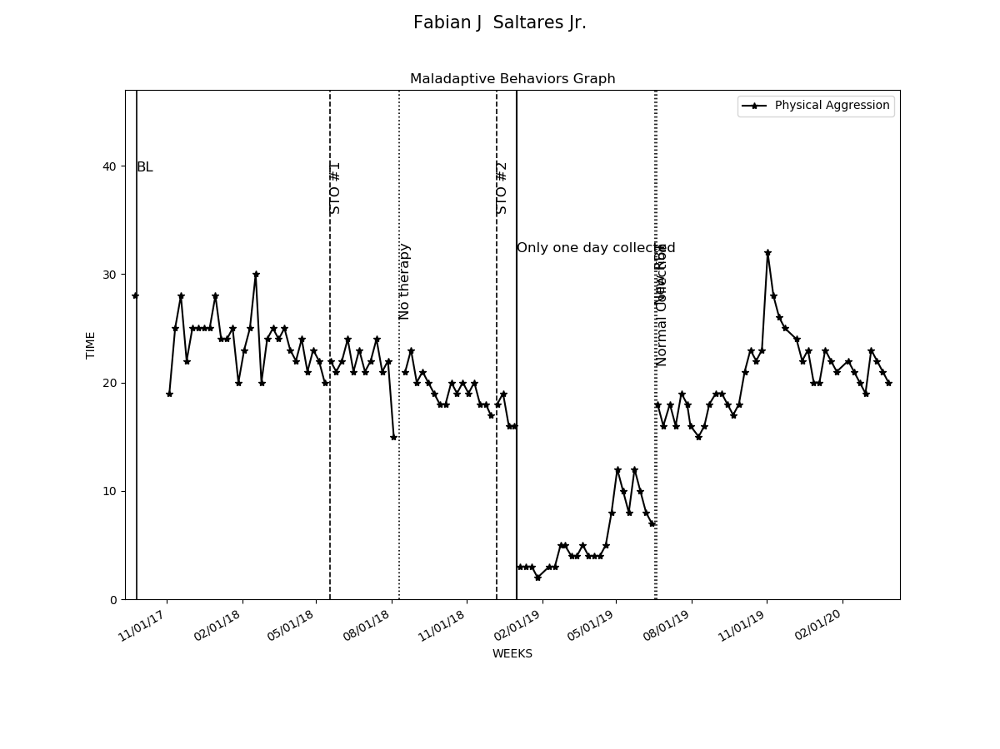

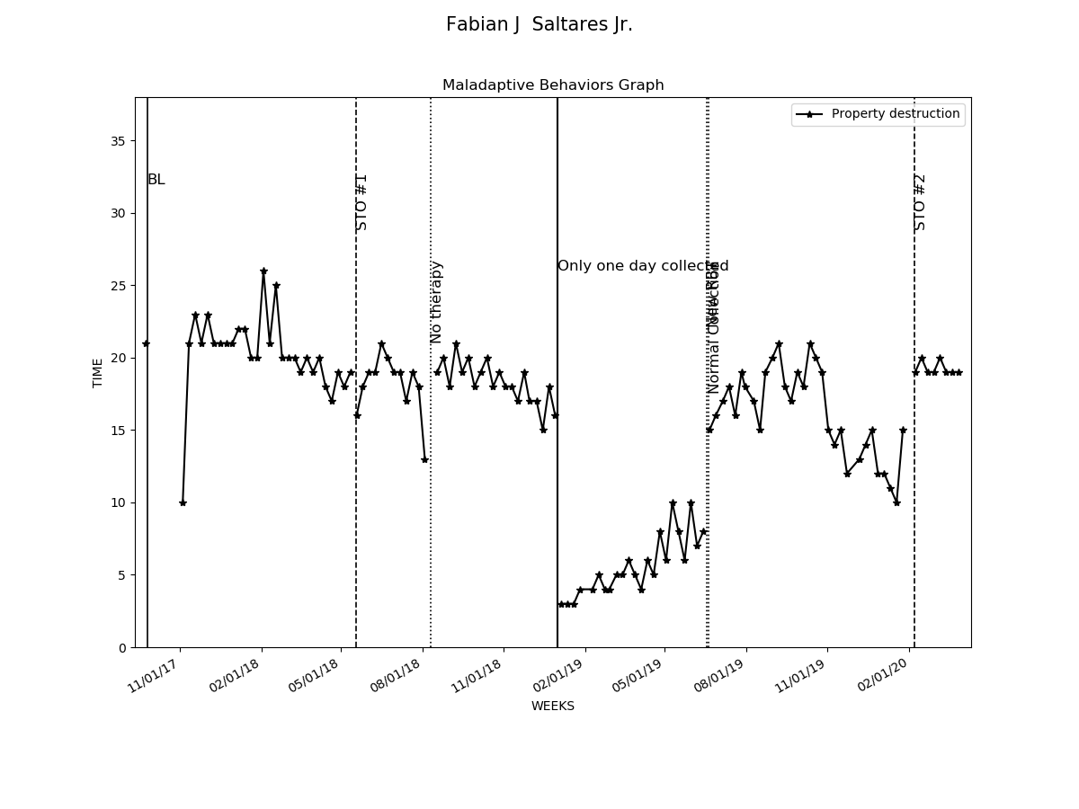

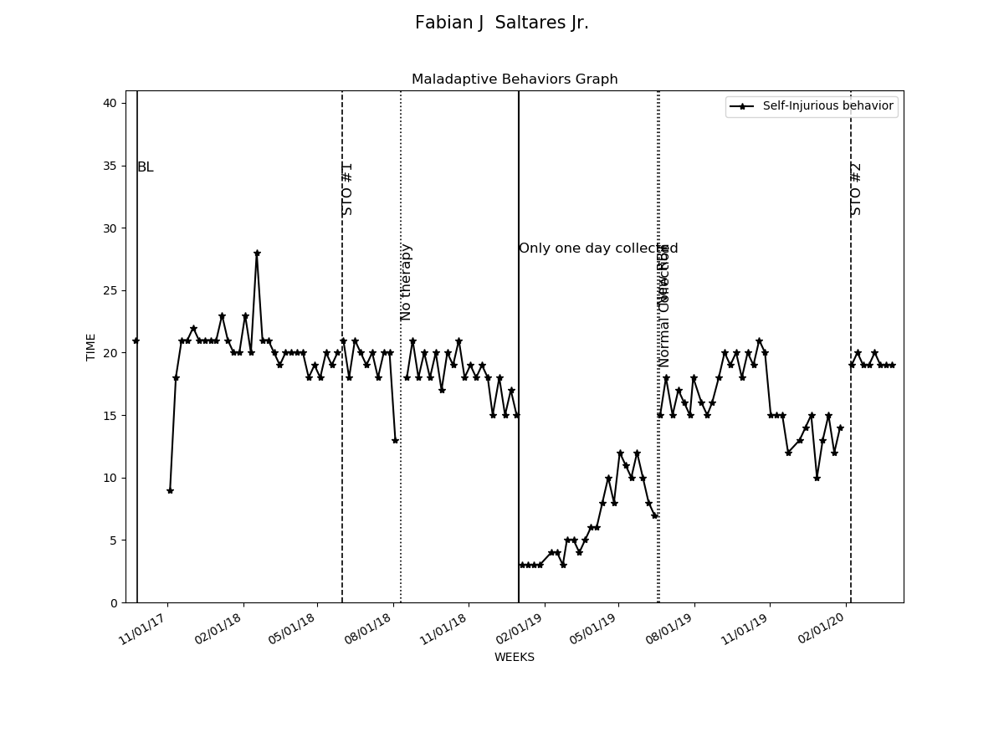

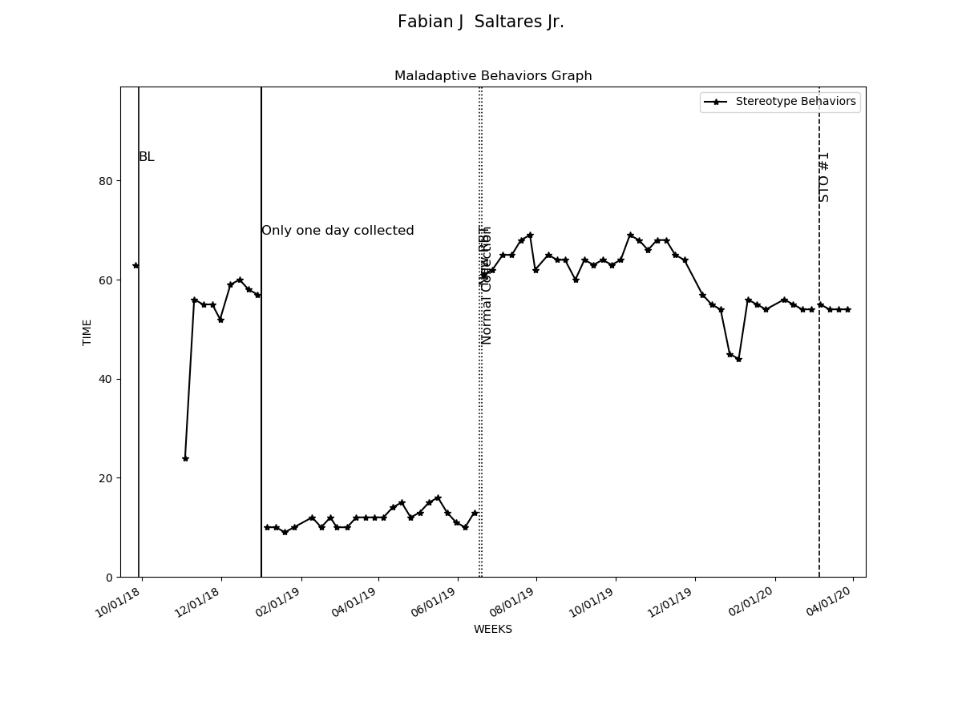

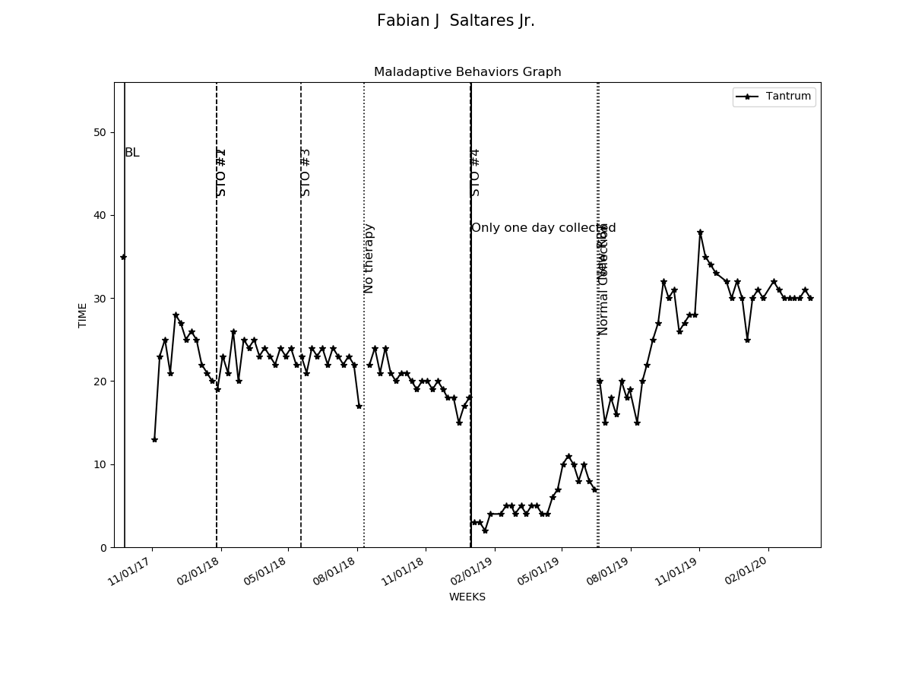

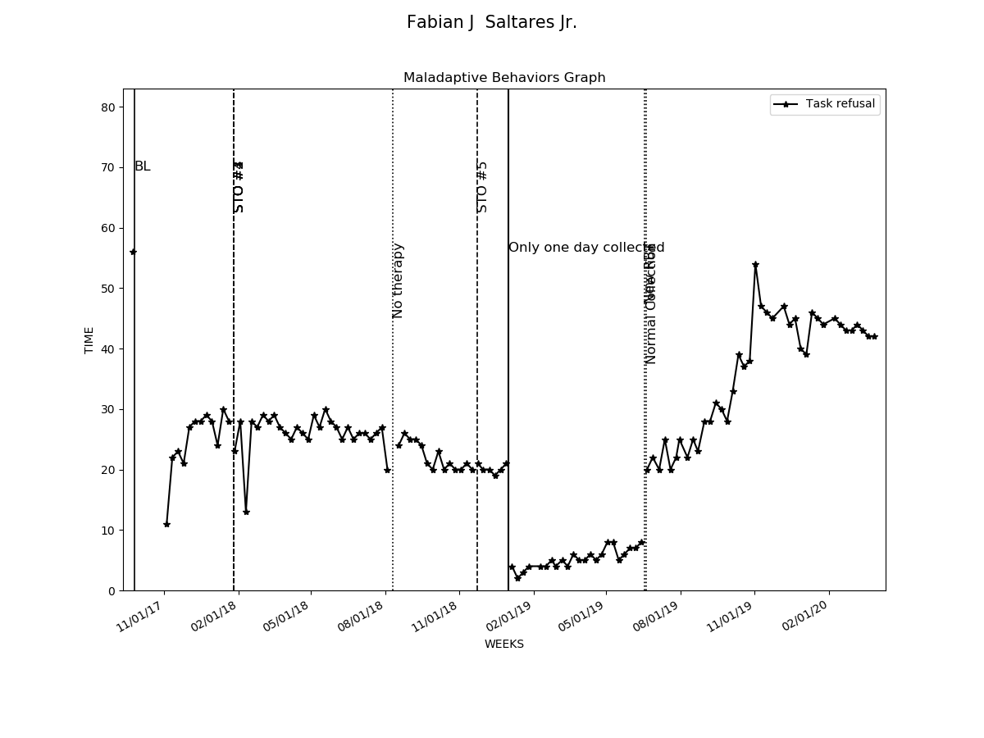

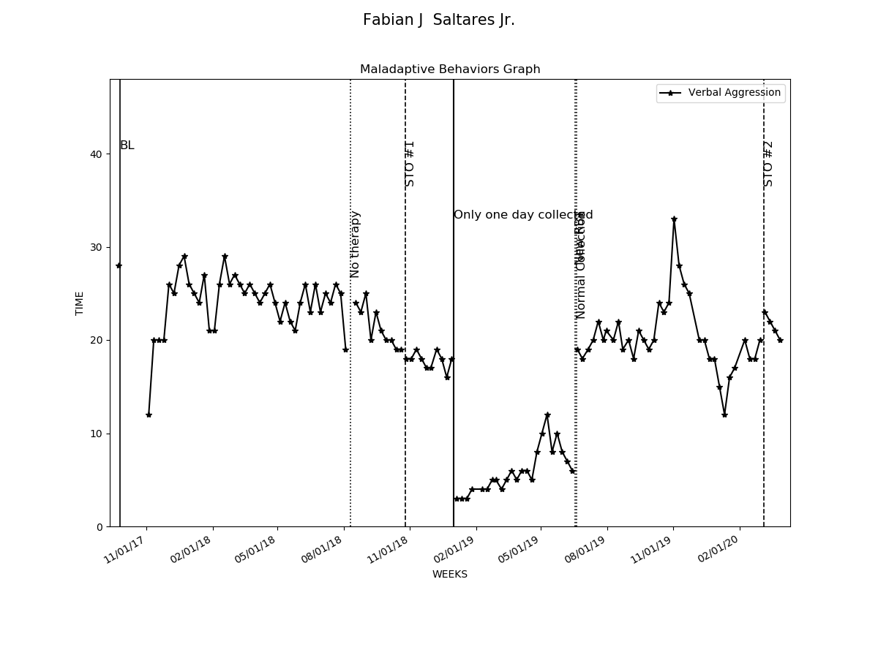

# Graphs Replacement and Interventions

|  |  |  |  |  |
| --- | --- | --- | --- | --- |
| Replacements and Programs | Baseline Date:2017-11-04to2017-11-07 | Current average per week (3/31/2020) | Status | Updated STO (3/31/2020) |
| 1- Request Break | 13% | 53% | In progress | Sto1(MASTERED 2018-07-14). Sto2(MASTERED 2020-02-29). Currently: STO 3(Initiated 3/1/2020) |
| 2- Request Attention | 13% | 53% | In progress | Sto1(MASTERED 2018-07-14). Sto2(MASTERED 2020-03-28). Currently: STO 3(Initiated 4/1/2020) |
| 3- Request Tangible | 16% | 53% | In progress | Sto1(MASTERED 2018-05-12). Sto2(MASTERED 2020-01-25). Currently: STO 3(Initiated 2/1/2020) |
| 4- Follow instructions | 16% | 53% | In progress | Sto1(MASTERED 2018-05-12). Sto2(MASTERED 2020-02-22). Currently: STO 3(Initiated 3/1/2020) |
| 5- Wait for Tangible | 10% | 51% | In progress | Sto1(MASTERED 2018-05-19). Sto2(MASTERED 2020-03-28). Currently: STO 3(Initiated 4/1/2020) |
| 6- Social Skills- Initiate and sustain interaction | 13% | 51% | In progress | Sto1(MASTERED 2018-01-27). Sto2(MASTERED 2018-12-29). Sto3(MASTERED 2019-12-28). Currently: STO 4(Initiated 1/1/2020) |
| 7- Social Skills- Taking turns during a play | 13% | 81% | LTO in progress | Sto1(MASTERED 2018-03-17). Sto2(MASTERED 2018-05-26). Sto3(MASTERED 2018-07-28). Sto4(MASTERED 2020-03-28). |
| 8- Social Skills- Ask for information | 13% | 51% | In progress | Sto1(MASTERED 2018-05-19). Sto2(MASTERED 2019-12-28). Currently: STO 3(Initiated 1/1/2020) |
| 9- Social Skills- Interrupt conversation | 13% | 52% | In progress | Sto1(MASTERED 2018-07-14). Sto2(MASTERED 2020-02-08). Currently: STO 3(Initiated 3/1/2020) |
| 10- Social Skills- Converse with other | 16% | 59% | In progress | Sto1(MASTERED 2018-03-10). Sto2(MASTERED 2019-10-19). Sto3(MASTERED 2020-03-28). Currently: STO 4(Initiated 4/1/2020) |
| 11- Social Skills- Accepting physical prompts | 16% | 52% | In progress | Sto1(MASTERED 2018-07-14). Sto2(MASTERED 2019-12-28). Currently: STO 3(Initiated 1/1/2020) |
| 12- Social Skills- Sharing toys | 17% | 51% | In progress | Sto1(MASTERED 2018-07-14). Sto2(MASTERED 2019-12-28). Currently: STO 3(Initiated 1/1/2020) |
| 13- Stay on task | 7% | 92% | In progress | Sto1(MASTERED 2019-12-28). Sto2(MASTERED 2020-03-28). Currently: STO 3(Initiated 4/1/2020) |
| 14- Remain seated | 10% | 53% | In progress | Sto1(MASTERED 2018-07-14). Sto2(MASTERED 2020-02-08). Currently: STO 3(Initiated 3/1/2020) |
| 15- Working independently | 13% | 94% | In progress | Sto1(MASTERED 2020-02-29). Currently: STO 2(Initiated 3/1/2020) |
| 16- Decreasing distractibility | 13% | 53% | In progress | Sto1(MASTERED 2018-07-14). Sto2(MASTERED 2020-02-08). Currently: STO 3(Initiated 3/1/2020) |
| 20- Make and maintain eye contact | 3% | 53% | In progress | Sto1(MASTERED 2019-11-23). Sto2(MASTERED 2019-12-28). Currently: STO 3(Initiated 1/1/2020) |
| 21- Sensory enrichment activities | 2% | 8% | In progress | Currently: STO 1 |
| 22- Parent Training - Data Collection | 0% | 44% | In progress | Sto1(MASTERED 2019-12-07). Sto2(MASTERED 2020-03-14). Currently: STO 3(Initiated 4/1/2020) |
| 23- Parent Training - Generalization of skills | 0% | 41% | In progress | Sto1(MASTERED 2019-12-21). Sto2(MASTERED 2020-03-28). Currently: STO 3(Initiated 4/1/2020) |

